Management by Objectives (MBO):
Most of the traditional methods of performance appraisal are subject to the antagonistic judgments of the raters. It was to overcome this problem; Peter F. Drucker propounded a new concept, namely, management by objectives (MBO) way back in 1954 in his book.
The Practice of management. The concept of MBO as was conceived by Drucker, can be described as a “process whereby the superior and subordinate managers of an organization jointly identify its common goals, define each individual’s major areas of responsibility in terms of results expected of him and use these measures as guides for operating the unit and assessing the contribution of each its members”.
In other words, stripped to its essentials, MBO requires the manager to goals with each employee and then periodically discuss his or her progress toward these goals.
In fact, MBO is not only a method of performance evaluation. It is viewed by the Practicing managers and pedagogues as a philosophy of managerial practice because .t .s a method by wh.ch managers and subordinates plan, organise, communicate, control and debate.
An MBO programme consists of four main steps: goal setting, performance standard, comparison, and periodic review. In goal-setting, goals are set which each individual, s to attain. The superior and subordinate jointly establish these goals. The goals refer to the desired outcome to be achieved by each individual employee.
In performance standards, the standards are set for the employees as per the previously arranged time period. When the employees start performing their jobs, they come to know what is to be done, what has been done, and what remains to be done.
In the third step the actual level of goals attained are compared with the goals agreed upon. This enables the evaluator to find out the reasons variation between the actual and standard performance of the employees. Such a comparison helps devise training needs for increasing employees’ performance it can also explore the conditions having their bearings on employees’ performance but over which the employees have no control.
Finally, in the periodic review step, corrective measure is initiated when actual performance deviates from the slandered established in the first step-goal-setting stage. Consistent with the MBO philosophy periodic progress reviews are conducted in a constructive rather than punitive manner.
The purpose of conducting reviews is not to degrade the performer but to aid in his/her future performance. From a motivational point of view, this would be representative of McGregor’s theories.
Figure 28.4 present the MBO method of performance appraisal presently used by an engineering giant i.e., Larsen and Turbro Limited.
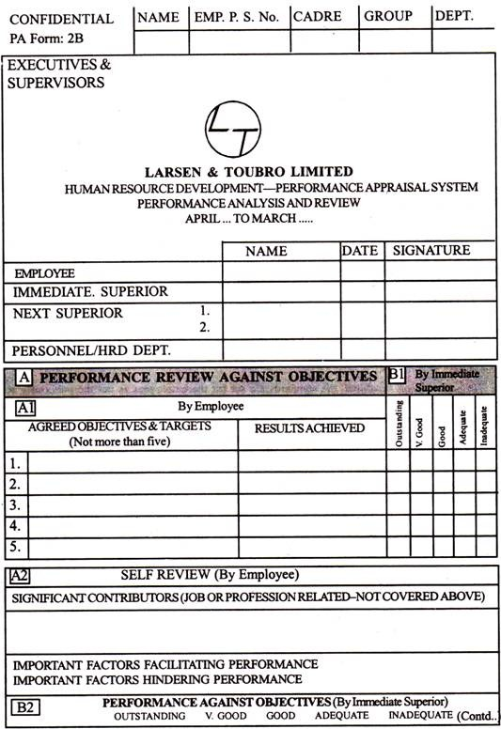
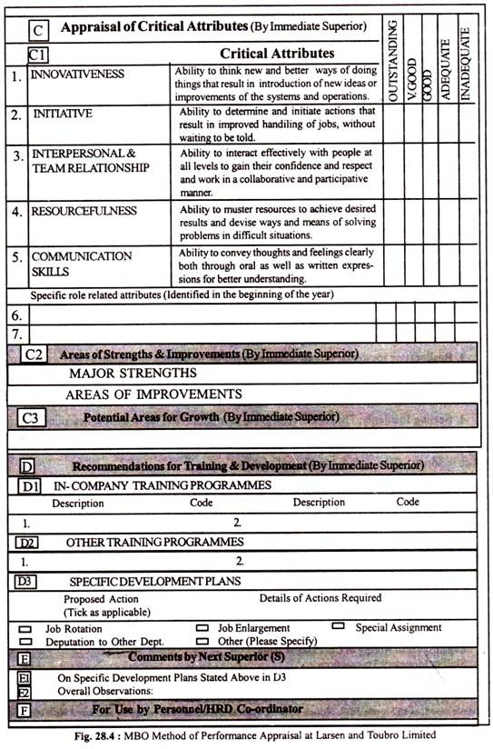
Limitation of MBO:
MBO is not a panacea, cure for all organisational problems.
As with other methods, it also suffers from some limitations as catalogued below:
(i) Setting Un-measurable Objectives:
One of the problems MBO suffers from is unclear and un-measurable objectives set for attainment. An objective such as “will do a better job of training” is useless as it is un-measurable. Instead, “well have four subordinates promoted during the year” is a clear and measurable objective.
(ii) Time-consuming:
The activities involved in an MBO programme such as setting goals, measuring progress, and providing feedback can take a great deal of time.
(iii) Tug of War:
Setting objectives with the subordinates sometimes turns into a tug of war in the sense that the manager pushes for higher quotas and the subordinates push for lower ones. As such, goals so set are likely to be unrealistic.
(iv) Lack of Trust:
MBO is likely to be ineffective in an environment where management has little trust in its employees. Or say, management makes decisions autocratically and relies heavily on external controls.

