“Coins”
Past and Present
Md. Azizur Rahman
Assistant Professor of Finance


A coin is a small, flat, round piece of metal or plastic used primarily as a medium of exchange or legal tender. They are standardized in weight, and produced in large quantities at a mint in order to facilitate trade. They are most often issued by a government.
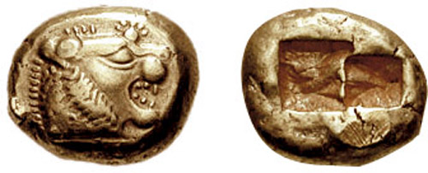
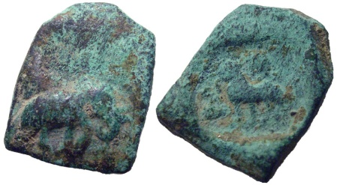
Coins are usually metal or alloy, or sometimes made of synthetic materials. They are usually disc shaped. Coins made of valuable metal are stored in large quantities as bullion coins. Other coins are used as money in everyday transactions, circulating alongside banknotes. Usually the highest value coin in circulation (i.e. excluding bullion coins) is worth less than the lowest-value note. In the last hundred years, the face value of circulation coins has occasionally been lower than the value of the metal they contain, for example due to inflation. If the difference becomes significant, the issuing authority may decide to withdraw these coins from circulation, possibly issuing new equivalents with a different composition, or the public may decide to melt the coins down or hoard them.
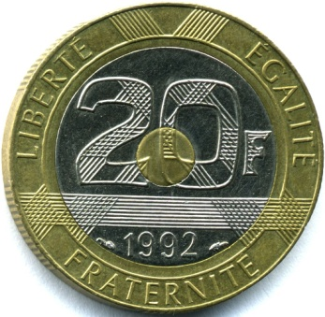
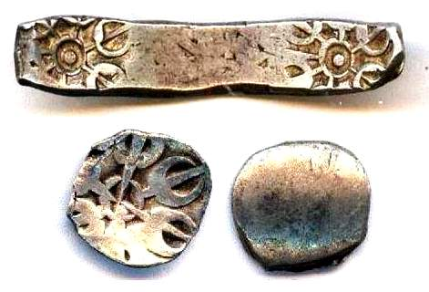
Exceptions to the rule of face value being higher than content value also occur for some bullion coins made of copper, silver, or gold (and, rarely, other metals, such as platinum or palladium), intended for collectors or investors in precious metals. Examples of modern gold collector/investor coins include the British sovereign minted by the United Kingdom, the American Gold Eagle minted by the United States, the Canadian Gold Maple Leaf minted by Canada, and the Krugerrand, minted by South Africa. While the Eagle, Maple Leaf, and Sovereign coins have nominal (purely symbolic) face values; the Krugerrand does not.
Historically, a great quantity of coinage metals (including alloys) and other materials (e.g. porcelain) have been used to produce coins for circulation, collection, and metal investment: bullion coins often serve as more convenient stores of assured metal quantity and purity than other bullion.
Historical “coins become “Bitcoin”
Bitcoin is a cryptocurrency, a digital asset designed to work as a medium of exchange that uses cryptography to control its creation and management, rather than relying on central authorities.^{[1]} The presumed pseudonymous Satoshi Nakamoto integrated many existing ideas from the cypherpunk community when creating bitcoin.
Bitcoin value history (comparison to US$)
Date | USD : 1 BTC | Notes
Jan 2009 – Apr 2010 | basically none | No exchanges or market, users were mainly cryptography fans who were sending bitcoins for hobby purposes representing low or no value. In March 2010, user "SmokeTooMuch" auctioned 10,000 BTC for $50 (cumulatively), but no buyer was found.
May 2010 | less than $0.01 | On 22 May 2010,Laszlo Hanyecz made the first real-world transaction by buying two pizzas in Jacksonville, Florida for 10,000 BTC.
July 2010 | $0.08 | In five days, the price grew 1000%, rising from $0.008 to $0.08 for 1 bitcoin.
Feb 2011 – April 2011 | $1.00 | Bitcoin takes parity with US dollar.
8 July 2011 | $31.00 | top of first "bubble", followed by the first price drop
Dec 2011 | $2.00 | minimum after few months
Dec 2012 | $13.00 | slowly rising for a year
11 April 2013 | $266 | top of a price rally, during which the value was growing by 5-10% daily.
May 2013 | $130 | basically stable, again slowly rising.
June 2013 | $100 | in June slowly dropping to $70, but rising in July to $110
Nov 2013 | $350 — $1,242 | from October $150–$200 in November, rising to $1,242 on 29 November 2013.
Dec 2013 | $600 — $1,000 | Price crashed to $600, rebounded to $1,000, crashed again to the $500 range. Stabilized to the ~ $650–$800 range.
Jan 2014 | $750 — $1,000 | Price spiked to $1000 briefly, then settled in the $800–$900 range for the rest of the month.
Feb 2014 | $550 — $750 | Price fell following the shutdown of Mt. Gox before recovering to the $600–$700 range.
Mar 2014 | $450 — $700 | Price continued to fall due to a false report regarding bitcoin ban in China and uncertainty over whether the Chinese government would seek to prohibit banks from working with digital currency exchanges.^{[105]}
Apr 2014 | $340 — $530 | The lowest price since the 2012–2013 Cypriot financial crisis had been reached at 3:25 AM on 11 April
May 2014 | $440 — $630 | The downtrend first slows down and then reverses, increasing over 30% in the last days of May.
Mar 2015 | $200 — $300 | Price fell through to early 2015.
Early Nov 2015 | $395 — $504 | Large spike in value from 225–250 at the start of October to the 2015 record high of $504.
May–June 2016 | $450 — $750 | Large spike in value starting from $450 and reaching a maximum of $750.
July–September 2016 | $600 — $630 | Price stabilized in the low $600 range.
October–November 2016 | $600 — $780 | As the Chinese Renminbi depreciated against the US Dollar, bitcoin rose to the upper $700s.
January 2017 | $800 — $1,150 | Dramatic Increase shown here…..
5-12 January 2017 | $750 — $920 | Price fell 30% in a week, reaching a multi-month low of $750.
2-3 March 2017 | $1,290+ | Price broke above the November 2013 high of $1,242 and then traded above $1,290.
Source: https://en.wikipedia.org/wiki/History_of_bitcoin

