Department of Environmental Science &Disaster Management organized a 'Field Visit' at Sylhet

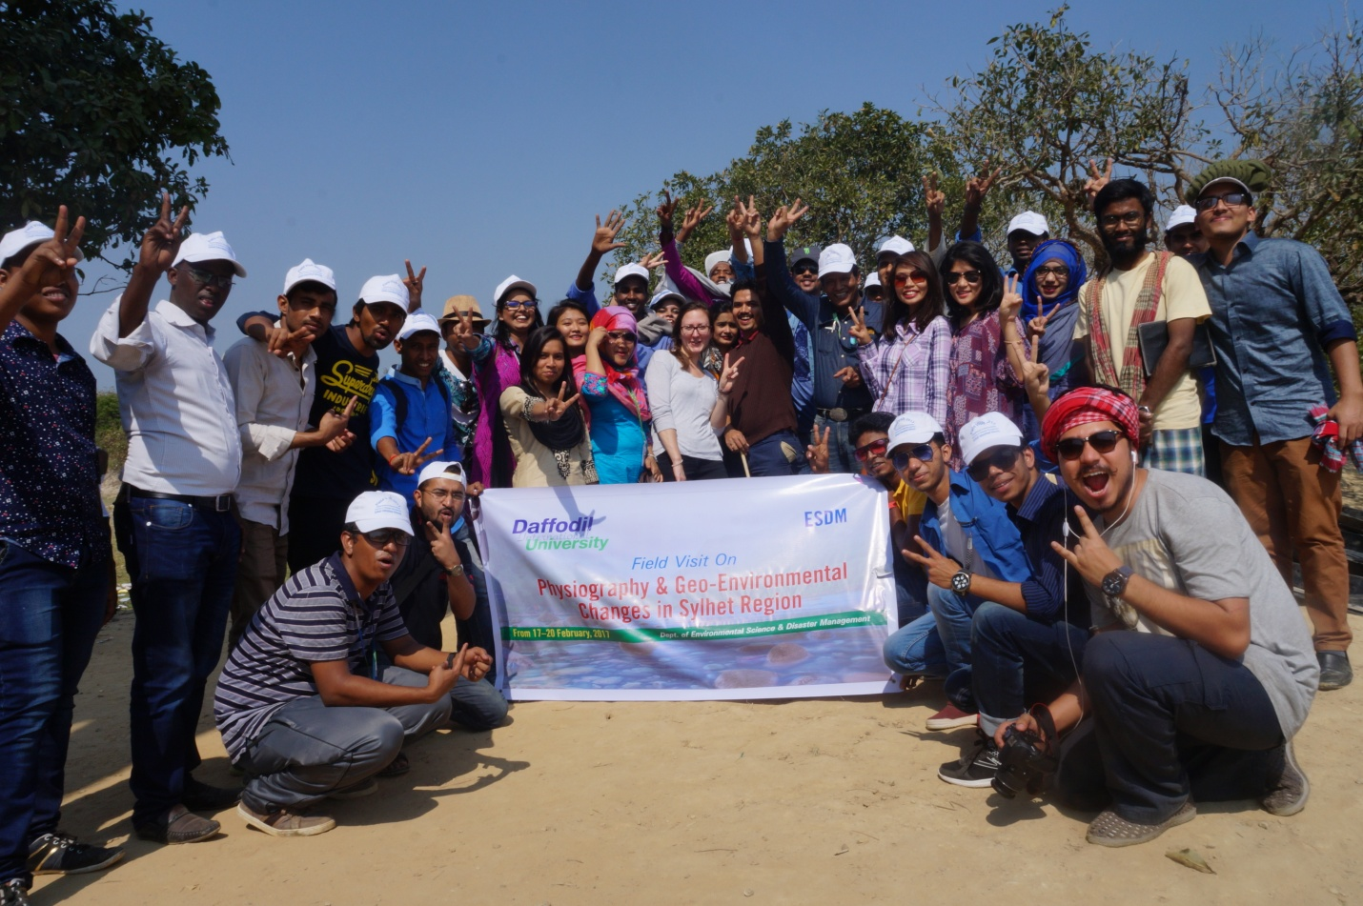
Students of Environmental Science and Disaster Management Department of Daffodil International University at 'Field Visit'
As a part of learning, students of ESDM Department of Daffodil International University have organized a 'Field Visit' at Sylhet recently. Students and Faculty members of the department lead by Dr. A. B. M. Kamal Pasha, Head of the Department of ESDM attended the Field Visit. They have visited Jaflong, Ratargul swamp forest, Bisnakandi, Llakhal located at Sylhet.
The Visit will help the students to observe physiography and environmental situation in Sylhet
region and also identify the place as a stone crushing area. For different reason the area is highly
contaminated for the people and life is seriously hampered. Students were able to identify the problem and did research on it.

