First step: Turnitin process to check plagiarism First need to lig in
User name and Password

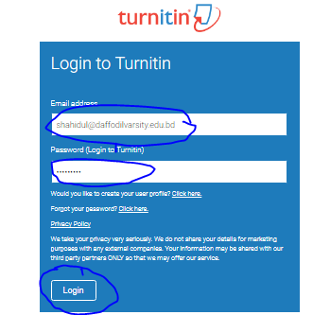
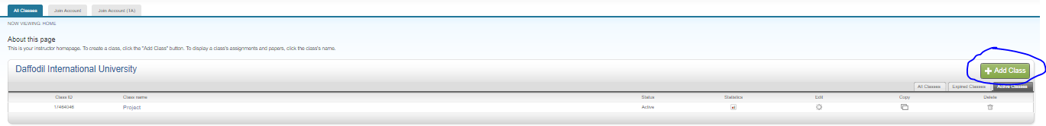
Step three: After clicking on Add it will show Create a new class will be shown

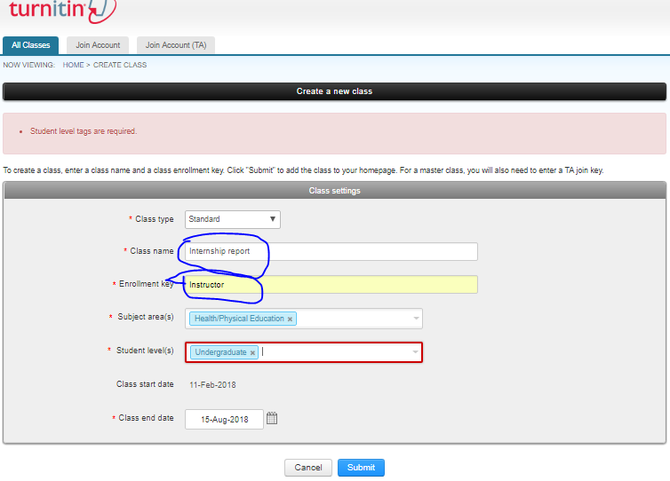
2nd Step: Add class

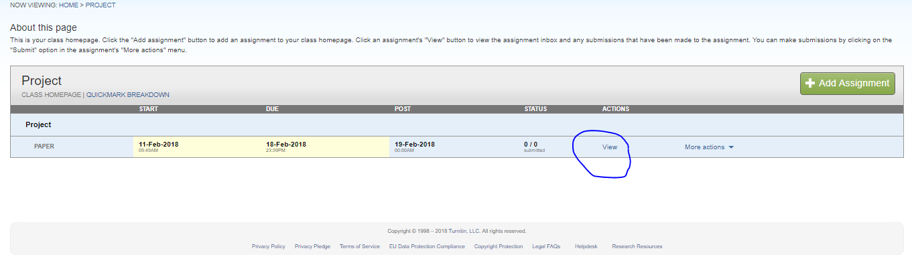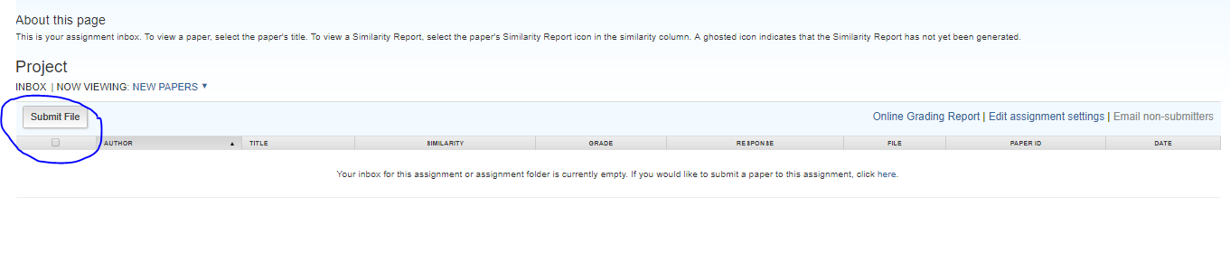
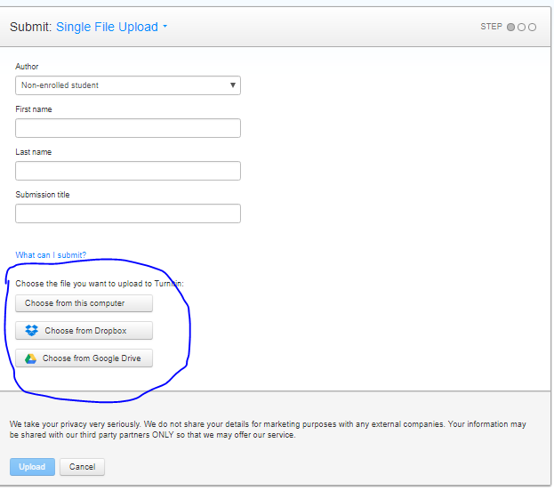
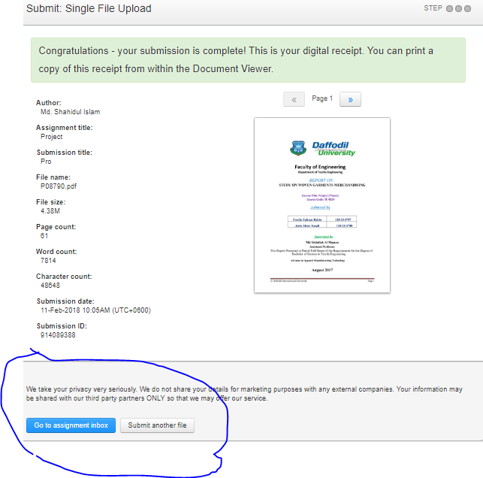
When a file is submitted the turnitin will show the result


