- About:
DIU Real Estate Association of Daffodil International University was formed to groom students’ professional attitude as well as enrich their corporate etiquette. Since 2008, the club has been glorifying the department of Real Estate through its dynamic activities. The efficient members of DIU Real Estate Association thrives on the unique perspectives and contributions that each of its members bring forward on campus, nationwide and abroad. However, this club was founded on 2009 and its very journey started with 03 members and now they are almost 10 permanent members and more than 120 participatory members. Now this club is standing as one of the most reputed clubs in DIU by the help of its most successful moderators 03 Thus, DIU Real Estate Association has now reached such a successful position.

- Contribution:
On the occasion of 16th foundation day 2018 of DIU, from DIU Real Estate Association two groups participated on the event of project presentation under the Faculty of Business and Entrepreneurship. Among the ten projects, one of the group from DIU Real Estate Association placed remarkable position being only group under the Faculty of Business and Entrepreneurship.
Moreover the volunteer role of DIU Real Estate Association was witnessed on the following programs:
SL. | Title/Topic | Name of the Institute | From (Date) - To (Date) | Year
 | DIU Real Estate Career Expo 2018 in cooperation with Real Estate Housing Association of Bangladesh (REHAB) | Department of Real Estate, Daffodil International University (DIU) | 19 July | 2018
 | Real Estate Business Plan Competition | Department of Real Estate, Daffodil International University (DIU) | 30 June | 2018
 | Training on:  Implementation of Outcome Based Approach to Curriculum of Department of Real Estate of DIU | Department of Real Estate, Daffodil International University (DIU) | 15 May | 2018
 | Seminar On:  Development of Necessary Skills for Writing Internship Report and Research Article | Department of Real Estate, Daffodil International University (DIU) | 7  October | 2018
 | Grooming Session on:  Experiences from Technical Visit to University of Malaya for Quality Enhancement in Higher Education | Department of Real Estate, Daffodil International University (DIU) | 30 September | 2018
 | Seminar on:  Relation Between Academic Study & Practical Knowledge at Real Estate Sector in Bangladesh; Perspective Assure Group | Department of Real Estate, Daffodil International University (DIU) | 30 July | 2018
 | Workshop on:  Implementation of Outcome Based Approach to Curriculum of Department of Real Estate of DIU | Department of Real Estate, Daffodil International University (DIU) | 15 May | 2018
 | Workshop on:  Preparation and submission of improvement plan of real estate department | Department of Real Estate, Daffodil International University (DIU) | 16 January | 2018

- Present Committee:
Department of Real Estate, FBE, DIU
“DIU Real Estate Association”
Current Committee, Date: September 30, 2018

S/L | Name | Position | ID & Batch | Mobile | E-Mail | Photo
01 | Md. Mostakim | President | 171-27-314, 27th Batch | 01780053713 | mostakim27-314@diu.edu.bd | 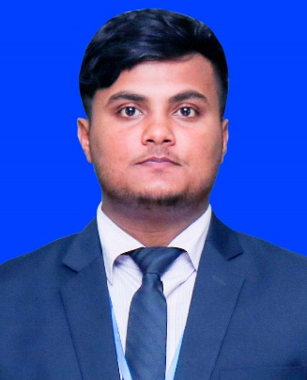
02 | Md. Abdur Rahim | General Secretary | 162-27-307, 25th Batch | 01631641751 | abdur27-307@diu.edu.bd | 
03 | Md. Rashidul Islam | Treasurer | 171-27-315, 27th Batch | 01706233006 | Rashidul27-315@diu.edu.bd | 
04 | Sumia Islam Sima | Organizing Secretary | 181-27-321, 28th Batch | 01710233801 | sumia27-321@diu.edu.bd | 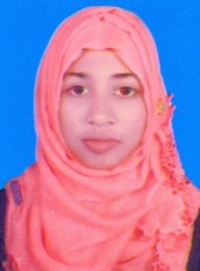
05 | Tanvir Ahmed Lipon | Executive Member | 153-27-297, 23rd Batch | 01683256544 | tanvir27-297@diu.edu.bd | 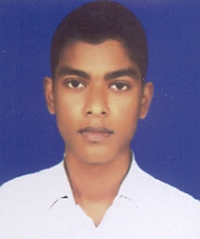

Convener | Mr. Md. Rayhanul Islam  Senior Lecturer  Department of Real Estate  ID: 710001254  Cell: +8801729703657 (Ext: 313)  E-mail: rayhanul.bba@diu.edu.bd | 
Co-convener | Mr. Nurul Mohammad Zayed  Assistant Professor & Head  Department of Real Estate  ID: 710001200  Cell: +8801715152526 (Ext: 309)  E-mail: headbre@daffodilvarsity.edu.bd,  zayed.bba@daffodilvarsity.edu.bd | 

Advisory Members:
S/L | Name | ID & Batch | Cell | E-Mail | E-mail
01 | Ms. Fatema Nusrat Chowdhury  Senior Lecturer  Department of Real Estate | 710001218 | 01680228933  (Ext: 313) | nusrat.bba@daffodilvarsity.edu.bd | 
02 | Mr. Md. Toki Yeasir  Assistant Coordination Officer  Department of Real Estate | 710002056 | 01811458884 (Ext: 308) | toki@daffodilvarsity.edu.bd | 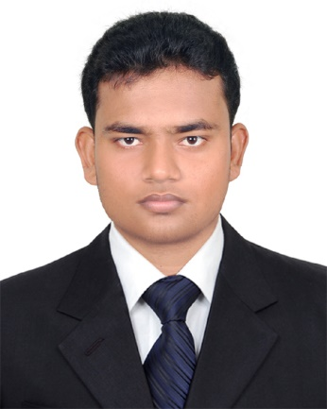
03 | Md.Al Mahamut Sunzit | 143-27-275, 20th Batch | 01737935939 | sunzit275@diu.edu.bd | 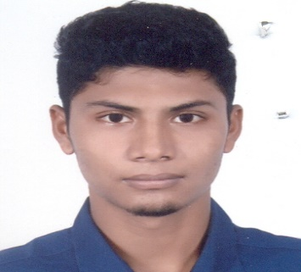
04 | Fatima Tuj Johra | 153-27-299, 22nd Batch | 01736500651 | fatima27-299@diu.edu.bd | 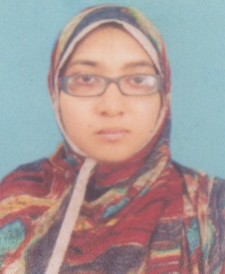

- Previous Committee:
DIU Real Estate Association
Department of Real Estate, FBE, DIU
Previous Committee, Date: November 06, 2017

S/L | Name | Posts | ID & Batch | Cell | E-mail | Photo
01 | Md.Al Mahamut Sunzit | President | 143-27-275, 20th Batch | 01737935939 | sunzit275@diu.edu.bd | 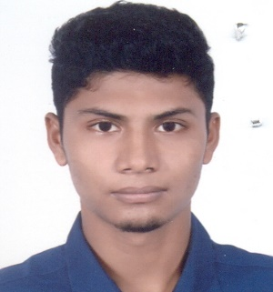
02 | Tanvir Ahmed Lipon | Vice President | 153-27-297, 22nd Batch | 01683256544 | tanvir27-297@diu.edu.bd
03 | Fairuz Farzana Suchona | General Secretary | 143-27-276, 20th Batch | 01706666555 | firuz276@diu.edu.bd | 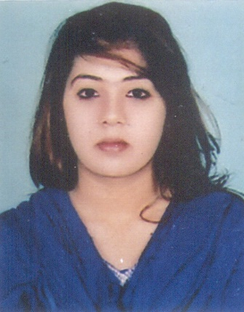
04 | Md. Manir Hossain | Joint Secretary | 152-27-288, 22nd Batch | 01625745395 | hossain27-288@diu.edu.bd | 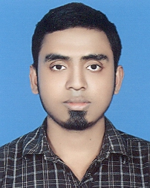
05 | Sabbir hasan | Treasurer | 151-27-281, 21st Batch | 01924365234 | sabbir27-281@diu.edu.bd | 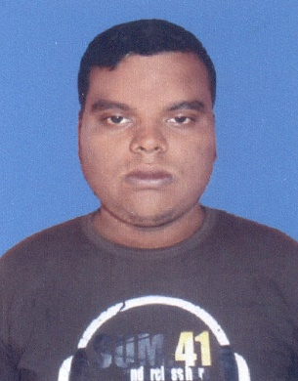
06 | M.S.Sakib | Organizing Secretary | 161-27-305, 24th Batch | 01516737112 | sakib27-305@diu.edu.bd | 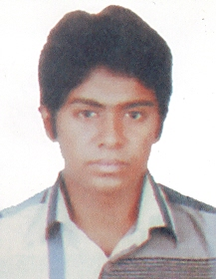
07 | Fatima Tuj Johra | Office secretary | 153-27-299, 22nd Batch | 01736500651 | fatima27-299@diu.edu.bd
08 | Md.Mostakim | Program Secretary | 171-27-314, 27th Batch | 01780053713 | mostakim27-314@diu.edu.bd | 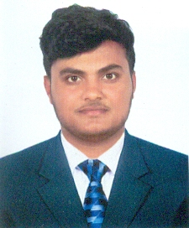
09 | Md. Al Mamun Khan | Ass. Program Secretary | 153-27-298, 22nd Batch | 01738172450 | mamun27-298@diu.edu.bd | 
10 | Md. Sohel Rana | Publication Secretary | 143-27-277, 20th Batch | 01721768312 | sohel277@diu.edu.bd | 

Convener | Mr. Sheikh Abdur Rahim  Associate Professor  Department of Real Estate  ID: 710000320  Cell: +8801713493090 (Ext: 379)  E-mail: rahim2008@daffodilvarsity.edu.bd | 
Co-convener | Mr. Nurul Mohammad Zayed  Assistant Professor & Head  Department of Real Estate  ID: 710001200  Cell: +8801715152526 (Ext: 309)  E-mail: headbre@daffodilvarsity.edu.bd,  zayed.bba@daffodilvarsity.edu.bd
Advisory Member | Mr. Md. Toki Yeasir  Assistant Coordination Officer  Department of Real Estate  Cell: +8801811458884 Ext: 308  toki@daffodilvarsity.edu.bd (Ext: 308)

