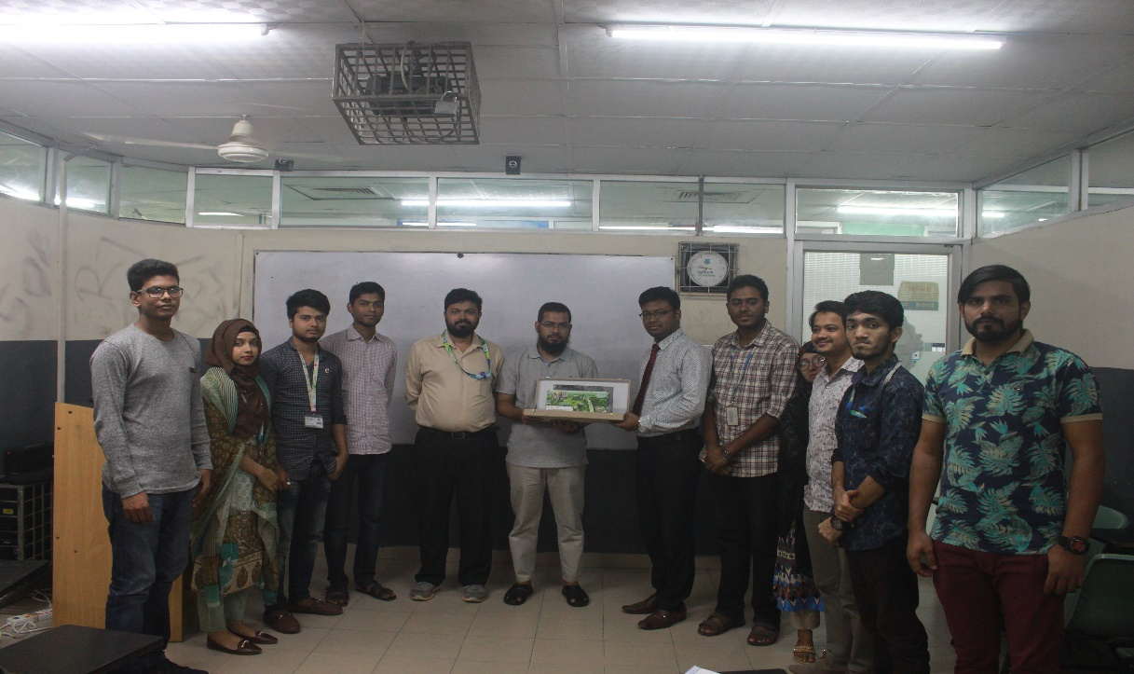
Mr. Saiful Islam, Mr. Rayhanul Islam (Senior Lecturer, Department of Real Estate) pose for a photograph with the participants of the seminar.
The Department of Real Estate organized a seminar on “Application of ArcGIS (Software) in Real Estate Marketing & Management” on 29 & 30 October 2018 and 05 & 06 November 2018 at Room No.-708, 7th Floor, DT. ArcGIS software is a powerful tool for informed decision making in any Real-Estate project. Considering the importance of ArcGIS in real-estate curriculum, the Department of Real Estate organized this seminar. The key person for the seminar was Mr. Saiful Islam, who is a graduate of Urban and Regional Planning from BUET, '98 batch. Mr. Islam has extensive working experience in both public and private sectors, and with multilateral and bilateral organizations. In addition he is a regular guest lecturer at public and private universities, as well as Bangladesh Institute of Planners (BIP) on ArcGIS software.
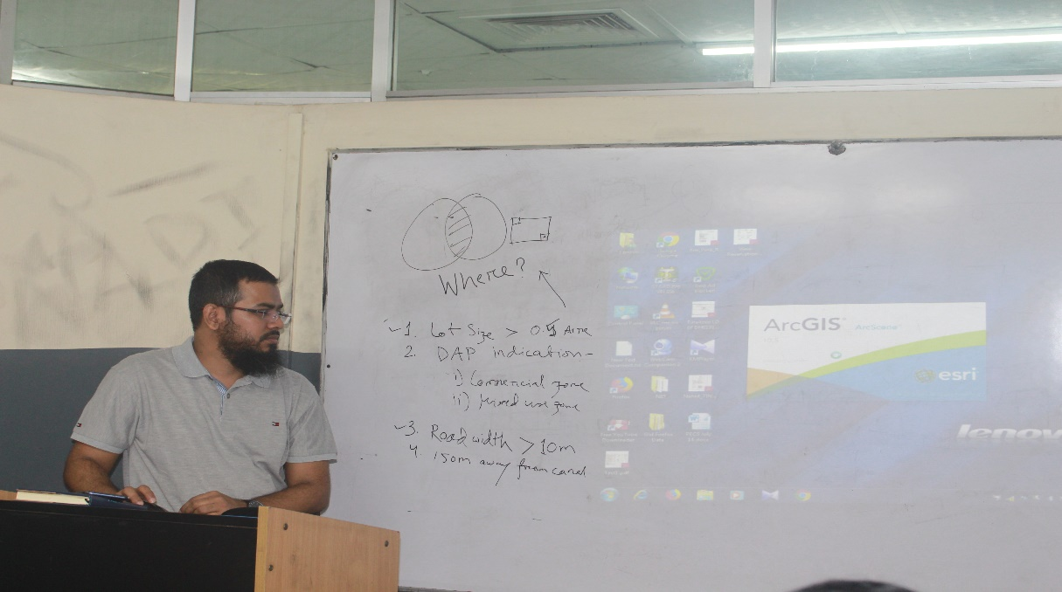
Mr. Saiful Islam delivering speech on the seminar on "Application of ArcGIS (Software) in Real Estate Marketing & Management”
He introduced the BRE program students with the ArcGIS 10.5 software interface, tools, and various analysis methods. In addition a real-time Real-Estate Project site selection process was demonstrated using the ArcGIS software. The seminar was ten (10) hours long and conducted over a four (4) days period within October 29 to November 06, 2018. This seminar is a part of the GIS-301: Geographical Information System in Real Estate course. Mr. Nurul Mohammad Zayed (Head, Department of Real Estate) thanked Mr. Saiful Islam for sharing his valuable time and knowledge with BRE program students. He also thanked Mr. Nahid hossain (Assistant Professor, Department of Civil Engineering) for his support in organizing such an important seminar on ArcGIS. The Seminar ended with the discussion for the development of Real Estate Department.

