Overview of Financial Institutions in Bangladesh
Introduction:
Financial sector reform in Bangladesh started in 1976 with privatization of the banks to encourage private investment, and continue in the mid-1980s as part of Structural Adjustment Policies (SAP). Between 1992 and 1996, a Financial Sector Reform Programme (FSRP) was implemented. Its major aim was to improve the operations of Nationalized Commercial Banks (NCBs) through the development of new banking technologies, computerization of banking operations, upgrading of skills, changing outdated internal banking practices and corporate and credit cultures. Further reforms are underway.In Bangladesh, there are 49 banks (with 6318 branches) of which there are 30 private commercial banks, 10 foreign commercial banks and 9 nationalized commercial and specialized banks. The banking sector employs about 110,000 people. Total deposits and loans and advances also increased considerably between 1990 and 2005 and some financial deepening has taken place as a result of intensive reforms in the financial system. Foreign joint venture banks now hold about 9.5 percent of the total assets of commercial banks.
Types of financial institutions:
- Commercial Banks
- Insurance companies
- Securities firms and investment banks
- Non banking financial institutions
- Mutual funds
- Pension funds
- Micro financial institutions

Commercial Bank
A financial institution that provides services, such as accepting deposits, giving business loans and auto loans, mortgage lending, and basic investment products like savings accounts and certificates of deposit. The traditional commercial bank is a brick and mortar institution with tellers, safe deposit boxes, vaults and ATMs. However, some commercial banks do not have any physical branches and require consumers to complete all transactions by phone or Internet. In exchange, they generally pay higher interest rates on investments and deposits, and charge lower fees.The commercial banks are :-
- Sonali Bank Limited
- Janata Bank Limited
- Agrani Bank Limited
- Rupali Bank Limited

Private commercial banks
• AB Bank Limited
• Bangladesh Commerce Bank Limited
• Bank Asia Limited
• BRAC Bank Limited
• Dhaka Bank Limited
• Dutch Bangla Bank Limited
• Eastern Bank Limited
• IFIC Bank Limited
• Jamuna Bank Limited
• Meghna Bank Limited

Thrift Bank:
A financial institution focusing on taking deposits and originating home mortgages. Thrift banks often have access to low-cost funding from Federal Home Loan Banks, which allows for higher savings account yields to customers and increased liquidity for mortgage loans.
Also known as "savings and loan associations".
Insurance companies:
A business that provides coverage, in the form of compensation resulting from loss, damages, injury, treatment or hardship in exchange for premium payments. The company calculates the risk of occurrence then determines the cost to replace (pay for) the loss to determine the premium amount. A protection against the loss of income that would result if the insured passed away. The named beneficiary receives the proceeds and is thereby safeguarded from the financial impact of the death of the insured.The insurance companies are:-
- Jiban Bima Corporation
- NATIONAL LIFE INSURANCE CO. LTD
- Delta Life Insurance Co. Ltd.
- Baira Life Insurance Company Ltd.

Securities
Evidence of a corporation's debts or property.
Securities are documents that merely represent an interest or a right in something else; they are not consumed or used in the same way as traditional consumer goods
Types of securities include notes, stocks, treasury stocks, bonds, debentures, certificates of interest or participation in profit-sharing agreements, collateral-trust certificates, preorganization certificates or subscriptions, transferable shares, investment contracts, voting-trust certificates, certificates of deposit for a security.

Finance company

an institution engaged in such specialized forms of financing as purchasing accounts receivable, extending credit to retailers and manufacturers, discounting installment contracts, and granting loans with goods as security.

Mutual fund

An open-ended fund operated by an investment company which raises money from shareholders and invests in a group of assets, in accordance with a stated set of objectives

Pension Fund

A fund established by an employer to facilitate and organize the investment of employees' retirement funds contributed by the employer and employees. The pension fund is a common asset pool meant to generate stable growth over the long term, and provide pensions for employees when they reach the end of their working years and commence retirement.

Percentage shares of assets of financial institutions :

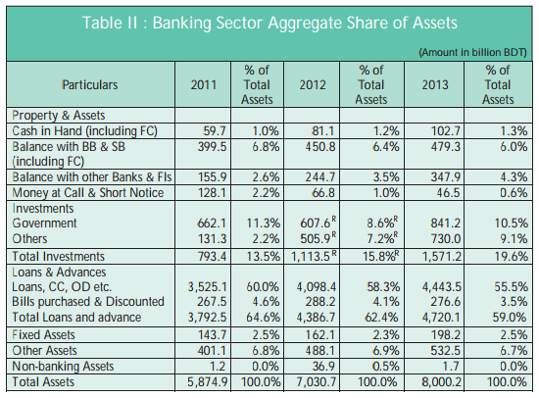

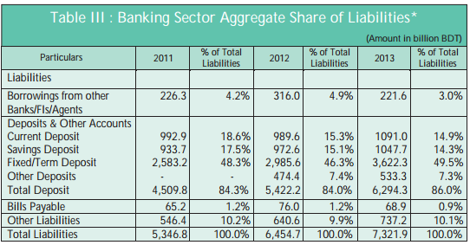

Conclusion:

The financial sector of Bangladesh is generally small and underdeveloped. This sector consists of a banking segment and an emerging but still nascent capital market segment. The banking segment in the country is relatively more developed than the equity market segment, even though both are quite underdeveloped in international comparison. The root causes of the Bangladeshi financial sector problem are the lack of market discipline due to lack of competition in the banking industry. Excessive government intervention and political connections, economic and political corruptions, operational and managerial inefficiency and ineffectiveness result in vicious circle that inhibits economic development, industrialization, and social progresses in poor and developing countries in general and in Bangladesh in particular. Authors’ suggested that in the financial regulation should be strengthened and further needed reforms should be carried out. In addition, an ombudsman may be appointed in the financial sector. The ombudsman can act independently to investigate any complaints regarding financial services and must work freely and independently. Better financial services and diversified financial products would be the natural consequence of competitive financial industry. The authors argue that a strengthened regulatory environment and additional much needed financial sector reforms, a better and more efficient financial sector may evolve over time and serve better the development needs of the country.

References:

ASSIGNMENT POINT (2011) Financial overview of Bangladesh.[Online] available from: http://assignmentpoint.com
GOOGLE (2014) List of insurance company in bd. [online] available from: http://google.com/businessdirectory.com

Datta, R, Mohajan, H.K. and. (2013), Financial Intermediaries in Development of Capital market in Bangladesh.

Fazlan Sufian (2007), Total Factor Productivity Change In Non-Bank Financial Institutions:Evidence From Malaysia Applying A Malmquist Productivity Index (MPI), Applied Econometrics and International Development Vol.7-1 (2007).

Ahmed, M. N., & Chowdhury, M. I. (2007). Non-bank financial institutions in Bangladesh:An analytical review. Working Paper Series: WP 0709, Bangladesh Bank, Bangladesh.

