The Ultimate Guide to Digital Marketing

The perfect resource for beginner-to-advanced digital marketers looking to learn new skills or hone existing ones.
The Ultimate Guide to Digital Marketing is full of insights and strategy for business owners, marketing professionals, students, and anyone else looking to hone their current skills and get up to speed on the latest in digital marketing.
Read it now to build or refine your digital marketing plan without the false starts and missteps that come with doing it alone.
What is Digital Marketing?
Digital marketing is the act of promoting and selling products and services by leveraging online marketing tactics such as social media marketing, search marketing, and email marketing.
When you get down to it, digital marketing is simply marketing.
It's how today's businesses are getting their message in front of their best prospects and customers.
Rule #1 in marketing is to make the right offer at the right time and in the right place. Today, your customers are online: hanging out in social media, staying updated on news sites and blogs, and searching online when they have a need.
Digital marketing puts you in those same channels, so your best prospects can see you, learn more about you, and even ask questions to learn more about you and your products or services.
If you're new to digital marketing, it may feel overwhelming to think about mastering all the online marketing tactics used in digital marketing.
We get that...
And yes, there are different tactics you'll need to learn. But they all work together to create a foundation for your business: attracting prospects, nurturing relationships, and making offers your audience will appreciate and respond to.
Let's take a closer look at how that happens.
How Does Digital Marketing Work?
In many ways, digital marketing is no different than traditional marketing. In both, smart organizations seek to develop mutually beneficial relationships with prospects, leads, and customers.
But digital marketing has replaced most traditional marketing tactics because it's designed to reach today's consumers.
As an example...
Think about the last important purchase you made. Perhaps you purchased a home, hired someone to fix your roof, or changed paper suppliers at your office.
Regardless of what it was, you probably began by searching the Internet to learn more about available solutions, who provided them, and what your best options were. Your ultimate buying decision was then based on the reviews you read, the friends and family you consulted, and the solutions, features, and pricing you researched.
Most purchasing decisions begin online.
That being the case, an online presence is absolutely necessary—regardless of what you sell.
The key is to develop a digital marketing strategy that puts you in all the places your followers are already hanging out, then using a variety of digital channels to connect with them in a multitude of ways...
...Content to keep them updated with industry news, the problems they're facing, and how you solve those problems...
...Social media to share that content and then engage with them as friends and followers...
...Search engine optimization (SEO) to optimize your content, so it will show up when someone is searching for the information you've written about...
...Advertising to drive paid traffic to your website, where people can see your offers...
...And email marketing to follow up with your audience to be sure they continue to get the solutions they're looking for.
When you put all these pieces together, you'll end up with an efficient, easy-to-operate digital marketing machine. And while it looks intimidating to build that machine from scratch, it's as simple as learning and integrating one digital marketing tactic at a time.
Which is why we've put together this guide: To help you build or refine your own digital marketing plan without the false starts and missteps that come with doing it alone.
What Are the Benefits of Digital Marketing?
Having a strong digital presence will help you in multiple ways:
- It will make it easier to create awareness and engagement both before and after the sale
- It will help you convert new buyers into rabid fans who buy more (and more often)
- It will kickstart word-of-mouth and social sharing—and all the benefits that come with them
- It will shorten the buyer's journey by presenting the right offers at the right time
Learn the Strategies That Get Real Results
Be aware, the digital marketing scene is ever changing. Gurus, podcasts, and bloggers declare a tool or tactic hot one week and dead the next.
The truth is, digital marketing is less about "digital" and more about "marketing," largely because digital marketing has come of age. Its fundamentals have already been established.
At DigitalMarketer, our objective is to clear the confusion about the tactics that work and how to use them to grow your business. We stand firmly against the so-called "gurus" who promote the next "shiny object" or "quick fix" that will reportedly kill email marketing, digital advertising, or search engine optimization.
Here, we're all about the fundamentals.
As you'll see in this guide, these 8 core disciplines of digital marketing will be critical to your business growth today, tomorrow, and for years to come. Each of these disciplines will be covered in depth in a chapter of this Ultimate Guide to Digital Marketing as shown below.
About The Ultimate Guide to Digital Marketing
Digital marketing isn't magic, and you don't need to be a computer whiz to be good at it. If you offer a product or service that the market desires, you can successfully market them in digital channels using the strategies taught in this guide.
The Ultimate Guide to Digital Marketing doesn't present hype about the latest flashy tactics in marketing—digital or otherwise. Instead, this resource covers foundational disciplines such as content marketing, social media marketing, and email marketing, always in the context of the goals that businesses care about.
These goals include acquiring new leads and customers, monetizing the leads and customers you already have, and creating communities of brand advocates and promoters.
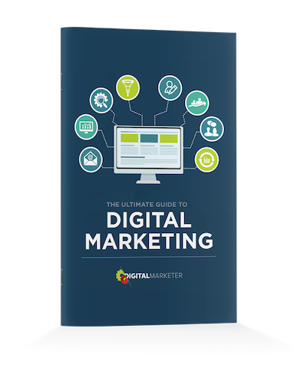

Want To Save This Guide For Later?
No problem! Just enter your email address and we'll send you the PDF of this guide for free.
Get Your FREE PDF
What You'll Learn
In each chapter, we'll cover 4 key aspects to the strategy being discussed:

The Methods: the strategies and processes you'll use to create your plan and execute it in your own business. This is the bulk of each chapter—because in digital marketing, how you execute a strategy is key. And in this Guide, we share the exact methods we use here at DigitalMarketer.

The Metrics: the numbers you'll watch to measure your success and identify areas that need tweaking (or are worth doubling down on).



The Lingo: the terminology used by experts, so you can communicate intelligently (even if you don't consider yourself a pro).

The Roles: the people in your organization who will likely have responsibility for planning and running each digital marketing tactic.


We've organized this Guide in a logical progression. Though you can jump around, learning the tactics in whatever order you feel you need them, we recommend you read through the chapters in order.
Take your time. Read and study one chapter at a time. Apply what you learn. And when you feel you've got the methods up and running, move on to the next chapter.
You'll be surprised at how quickly you can implement these digital marketing tactics if you focus on them one at a time. Then, when everything is up and running, you can focus on optimizing and improving your processes for maximum growth.
Ready to start?
Previous


