Assignment

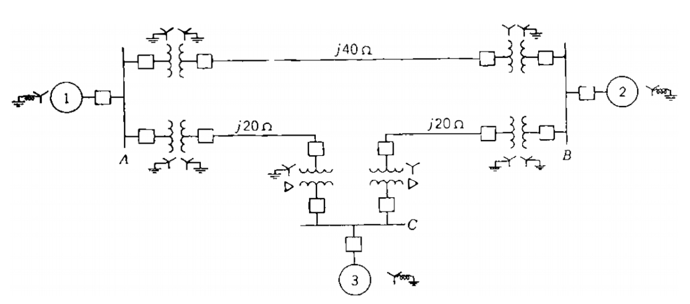
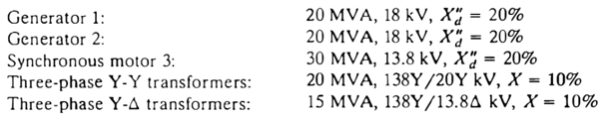
Draw the reactance diagram for the power system. Mark impedances in per unit. Neglect resistance and use a base of 50 MVA, 138 kV in the 40Ω line

