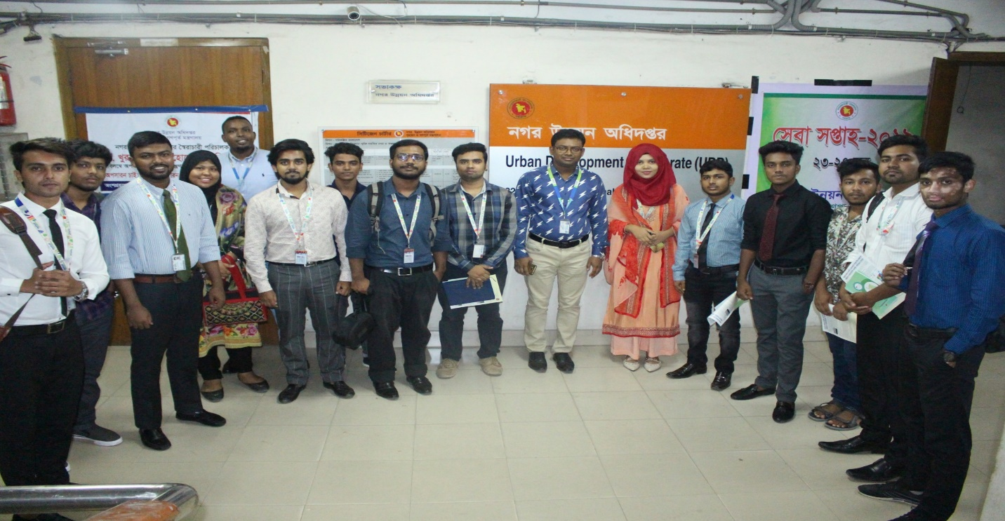
Mr. Rayhanul Islam (Senior Lecturer, Department of Real Estate) with the students of BRE Program at Urban Development Directorate (UDD); Government of the People's Republic of Bangladesh
The Department of Real Estate conducted an Industrial Visit at Urban Development Directorate (UDD); Government of the People's Republic of Bangladesh on 04 July 2019. The coordinator for the Industrial Visit was Mr. Md. Rayhanul Islam, who is Sr. Lecturer of Real Estate Department. A discussion session arranged by the UDD Authority at their conference room, which was conducted by Ms. Farzana Samiruddin (Deputy Director; Physical Planning). Mr. Sharif Mohammed Tariquzzaman (Senior Planner) also present a PowerPoint on present activities, various ongoing and upcoming plans of UDD and shared his thoughts and working experiences among the students.
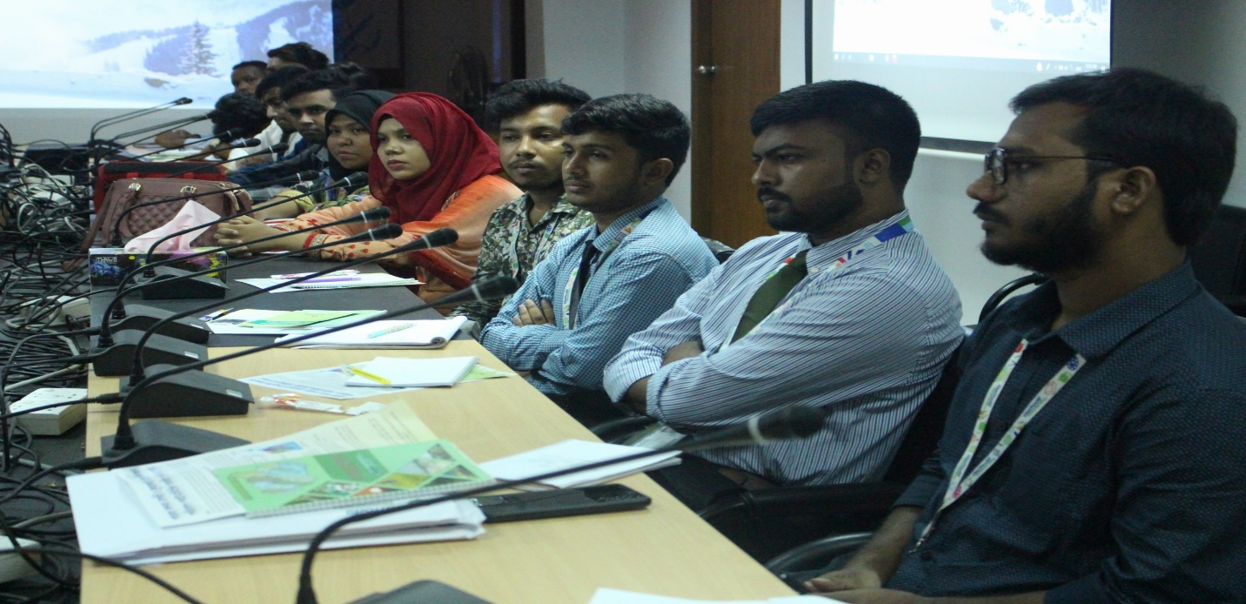
Students of Real Estate Department on the discussion session at Conference Room of Urban Development Directorate (UDD); Government of the People's Republic of Bangladesh
Ms. Farzana Samiruddin has extensive working experience in both public and private sectors and with multilateral and bilateral organizations. She introduced students with tools and techniques, and various methods to make them eligible to be a real estate planner. She said, Present government is working tirelessly to ensure housing for its every citizen. In this regard, UDD ensuring effective urban plan for better dwelling place for every citizen, keeping in mind the restoration of environment. She added, Daffodil International University has opened the Department of Real Estate for meeting the demand of real estate sector. It’s really an appreciative initiative. In the meantime she gave commitment that UDD will help the BRE students in terms of sharing any practical knowledge. Moreover, she invited to the Real Estate Family for visiting their ongoing projects. Mr. Rayhanul Islam thanked Ms. Farzana Samiruddin and Mr. Sharif Mohammed Tariquzzaman for sharing their valuable time and knowledge with the students and invited them to visit DIU. After the discussion session students visited their various project demo.

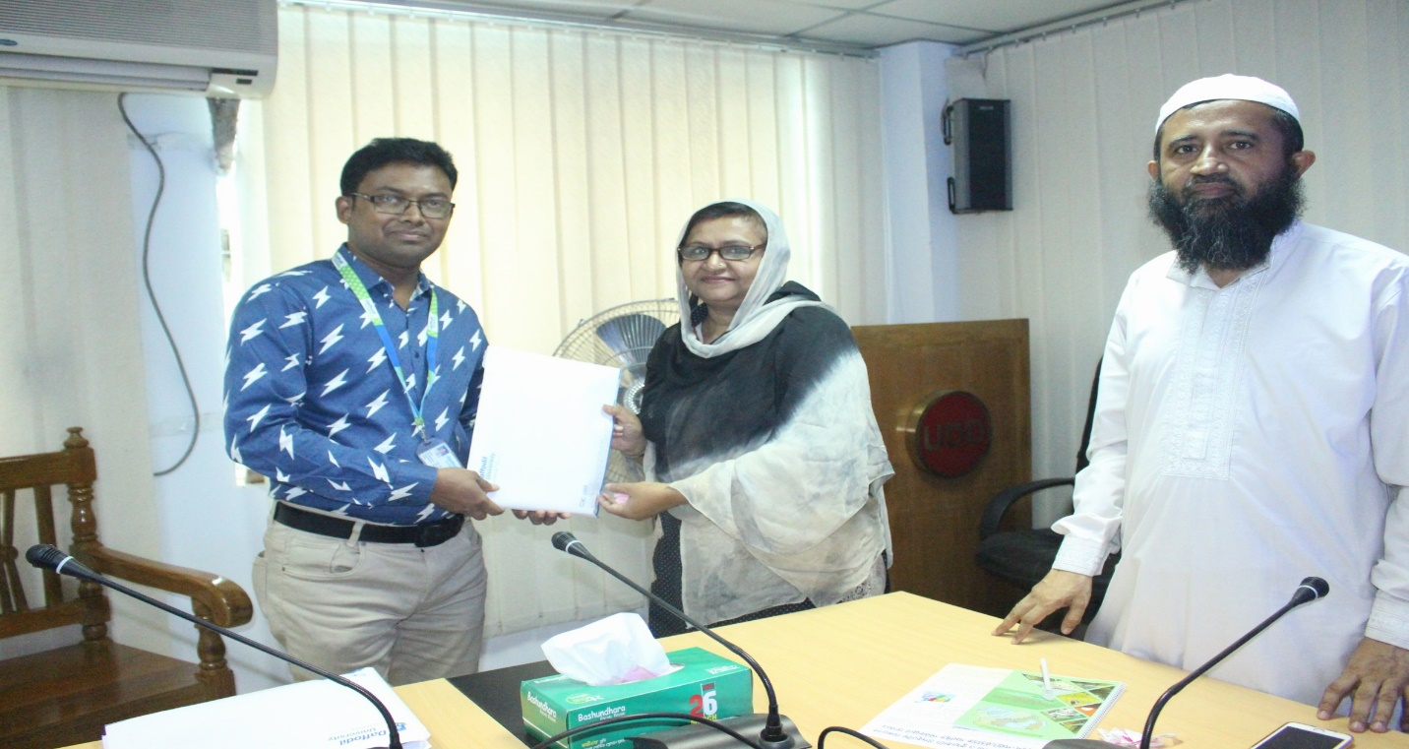
Mr. Rayhanul Islam (Senior Lecturer, Department of Real Estate) handed over the “DIU Souvenir and Course Curriculum of BRE Program” to Ms. Farzana Samiruddin (Deputy Director; Physical Planning) Urban Development Directorate (UDD); Government of the People's Republic of Bangladesh.

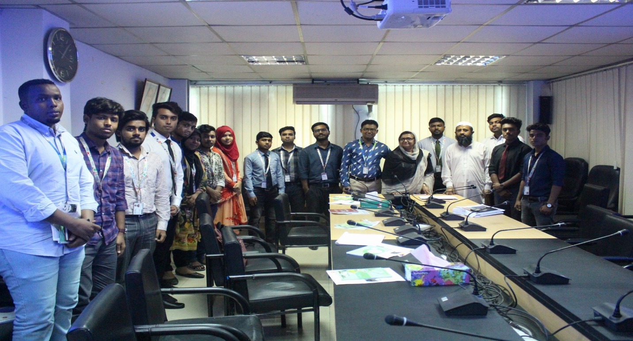
Real Estate Family with the high officials of Urban Development Directorate (UDD); Government of the People's Republic of Bangladesh

