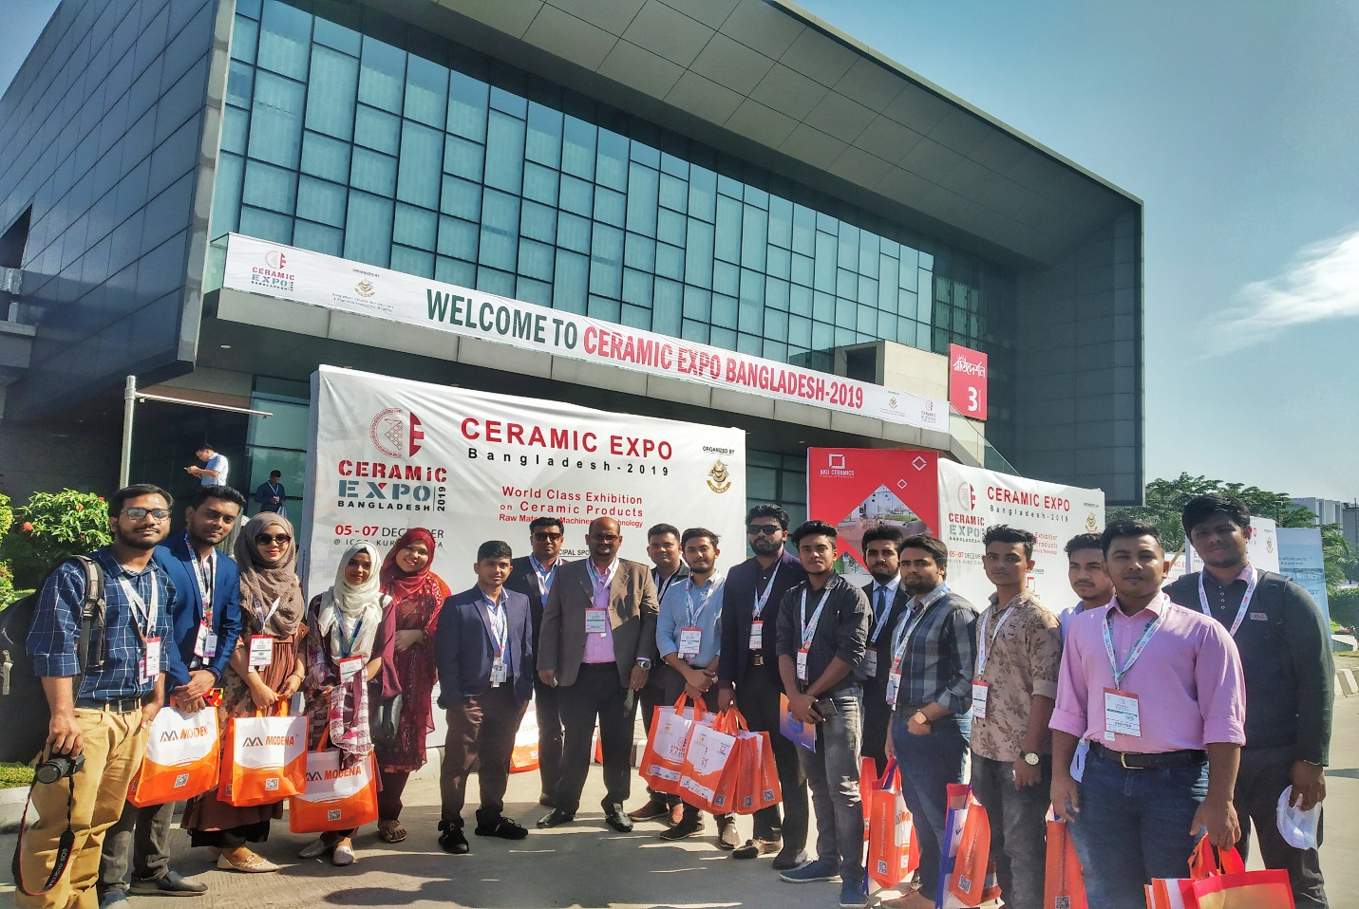

Ceramics industry has turned into a booming manufacturing sector in Bangladesh over the years, cashing in on growing demand both in domestic and international markets. Without ceramic industry, modern real estate sector cannot be considered. In view of this, The Department of Real Estate visited "Ceramic Expo; Bangladesh-2019" on 07 December 2019 (Saturday), at "International Convention City, Bashundhara, Kuril, Dhaka. Faculty members, officials along with the students of the department, arranged this day long tour as a part of the academic activities. Students introduced with the latest and modern technologies and got a vast idea regarding the ceramic industry as well as products, those are using in the current Real Estate Sector.


