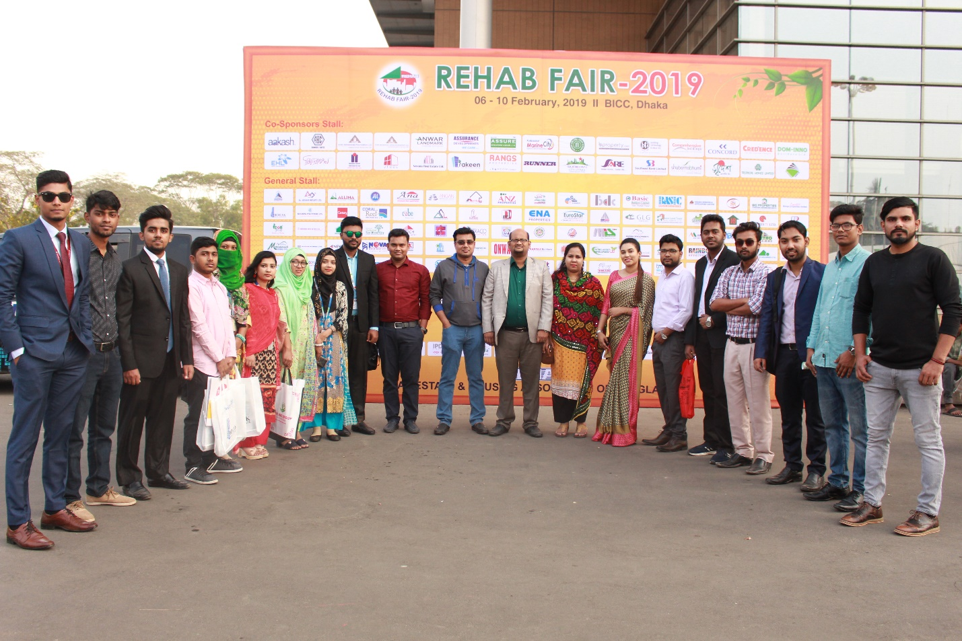

“REHAB FAIR-2019” held at Bangabandhu International Conference Center (BICC) from 06 February 2019 to 10 February 2019. As usual Real Estate Department visited “REHAB Fair-2019” on 09 February 2019 (Saturday) at Bangabandhu International Conference Center. We hope that, students caught a vast area of knowledge about various industrial sector as well as Real Estate arena and it helped them for their further career development purpose.

