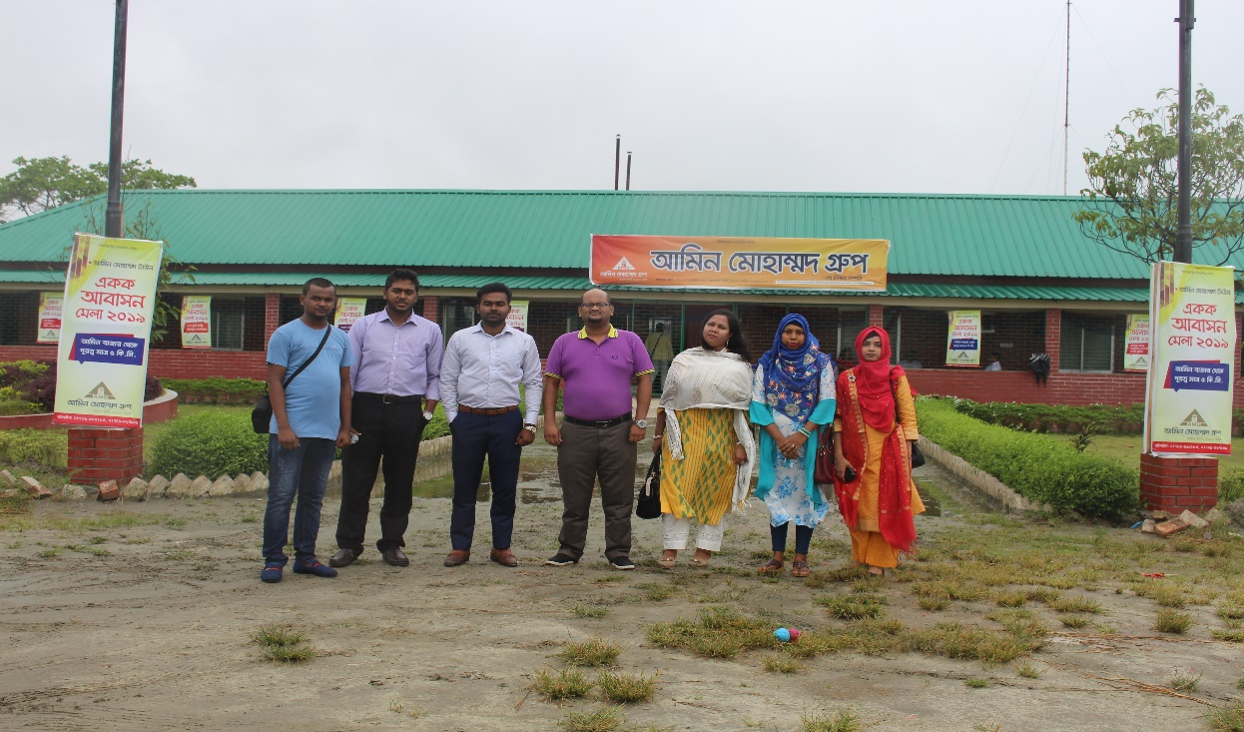

Department of Real Estate, Faculty of Business & Entrepreneurship, Daffodil International University organized a “Corporate Visit” successfully at “Amin Mohammad Group; Hemayetpur project, Savar, Dhaka” on 04 May 2019 for the senior students of the department. 05 Students along with Mr. Nurul Mohammad Zayed (Head of the department) attended in this Visit. Through this corporate visit students can learn the real estate companies’ activities practically, which will help them to become successful real estate managers or entrepreneurs.
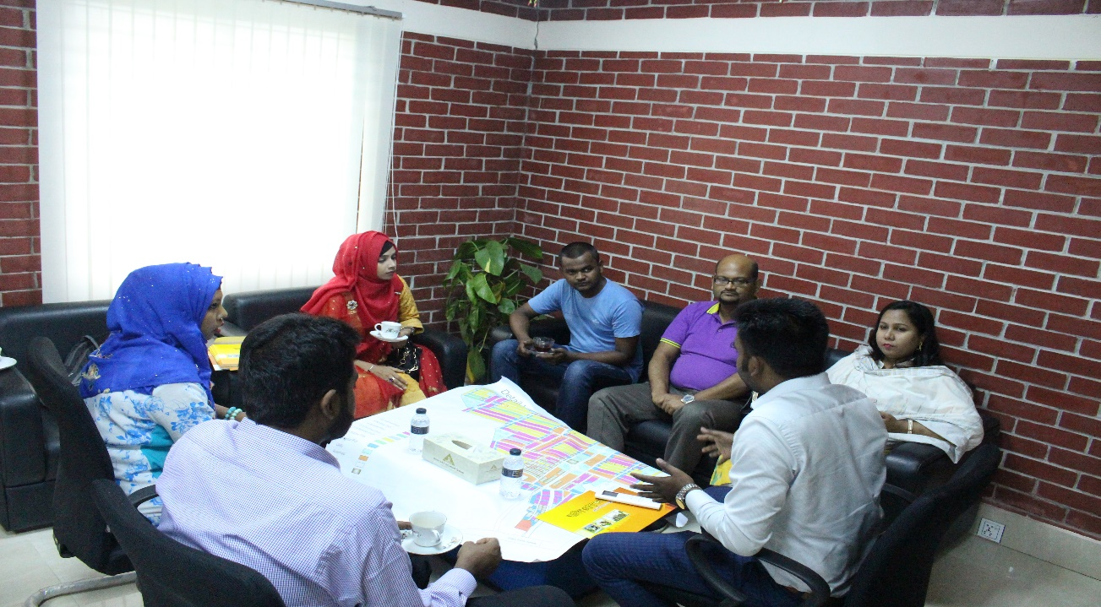
Mr. Sharhriar Kabir Emon (Alumni, DBA, DIU; Executive, Amin Mohammad Lands Development Ltd.) said that Present government is working tirelessly to ensure housing for its every citizen. In this regard, “Amin Mohammad Group” ensuring better dwelling place for every citizen, keeping in mind the restoration of environment. He said, Daffodil International University has opened the Department of Real Estate for meeting the demand of real estate sector. It’s really an appreciative initiative. In the meantime he said that, as usual Amin Mohammad Group will help the BRE graduates for their Internship and Job placement. He shared the activities of Amin Mohammad Group and his experiences in the field of real estate with practical examples. Moreover, he invited to the Real Estate Family for visiting their other projects. On behalf of the Amin Mohammad Group, he made all arrangements for the visit. The visit ended with the discussion for the development of Real Estate Department.

