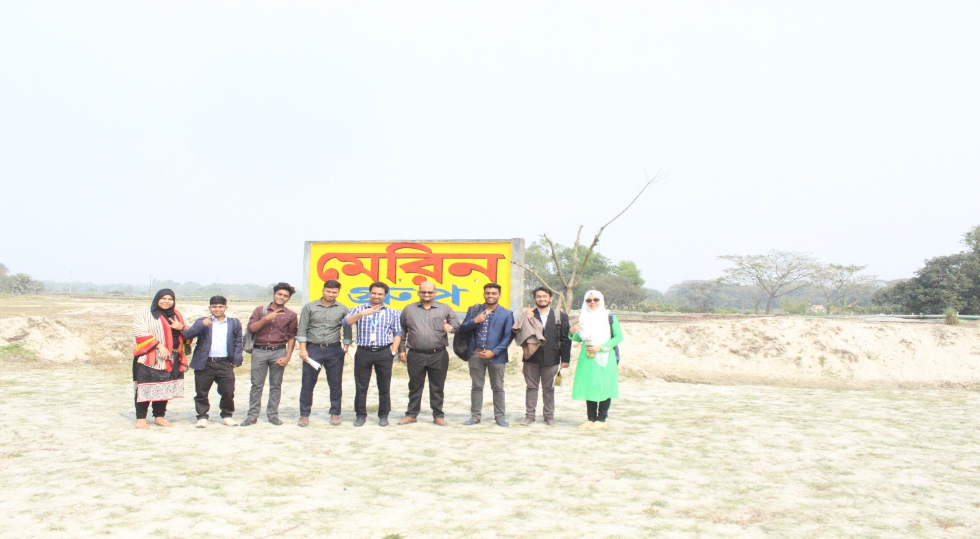
A team of 12 Students and Faculty Members of The Department of Real Estate Visited “Purbachal Marine City”; Zinda Park Rd, Rupganj, Narayanganj, Narayanganj-1462, on 17 February 2020 (Monday). Mr. Nurul Mohammad Zayed (Assistant Professor & Head, DRE) and Mr. Shakil Ahmed (Lecturer, DRE) were present to assist the team members. Through this field visit students can learn the real estate companies’ activities practically, which will help them to become successful real estate managers or entrepreneurs.
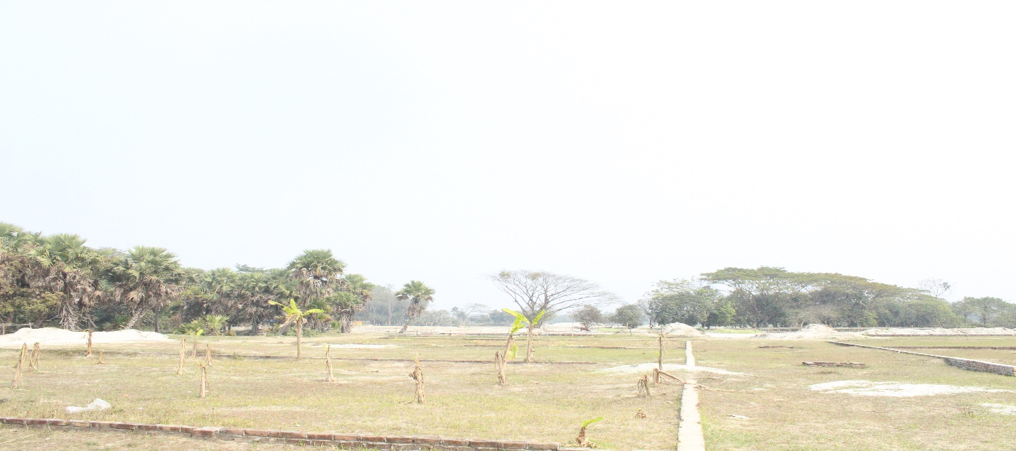
Project Area of “Purbachal Marine City”
Mr. Zubair Bin Zakaria (Senior Business Executive, Marine Group) said that Present government is working tirelessly to ensure housing for its every citizen. In this regard, “Purbachal Marine City” ensuring better dwelling place for every citizen, keeping in mind the restoration of environment. He said, Daffodil International University has opened the Department of Real Estate for meeting the demand of real estate sector. It’s really an appreciable initiative. In the meantime he said that, as usual ‘Marine Group’ will help the BRE graduates for their Internship and Job placement. He shared the activities of ‘Marine Group” and his experiences in the field of real estate with practical examples. Moreover, he invited to the Real Estate Family for visiting their other projects. On behalf of the “Marine Group”, he made all arrangements for the visit. The visit ended with the discussion for the development of Real Estate Department.
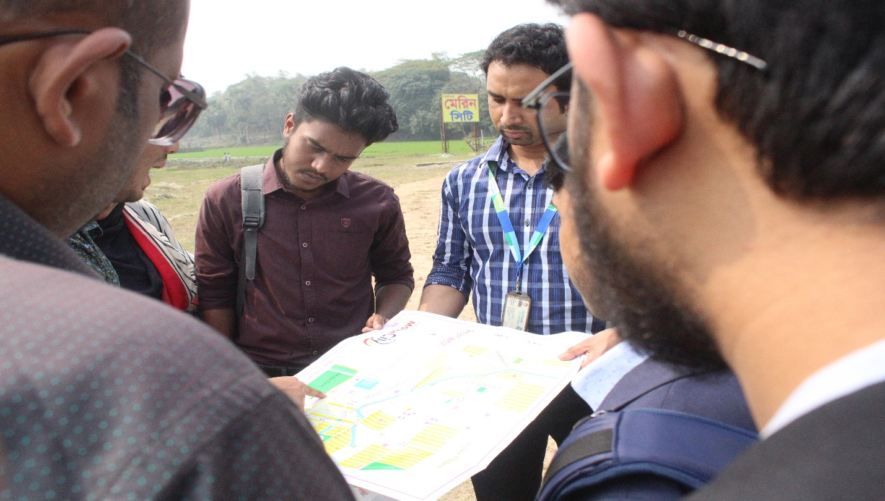
Students are gathering knowledge from the ‘Project Map’ and planning of “Purbachal Marine City”

