Intra Departmental Poster Competition held at Department of Real Estate, DIU
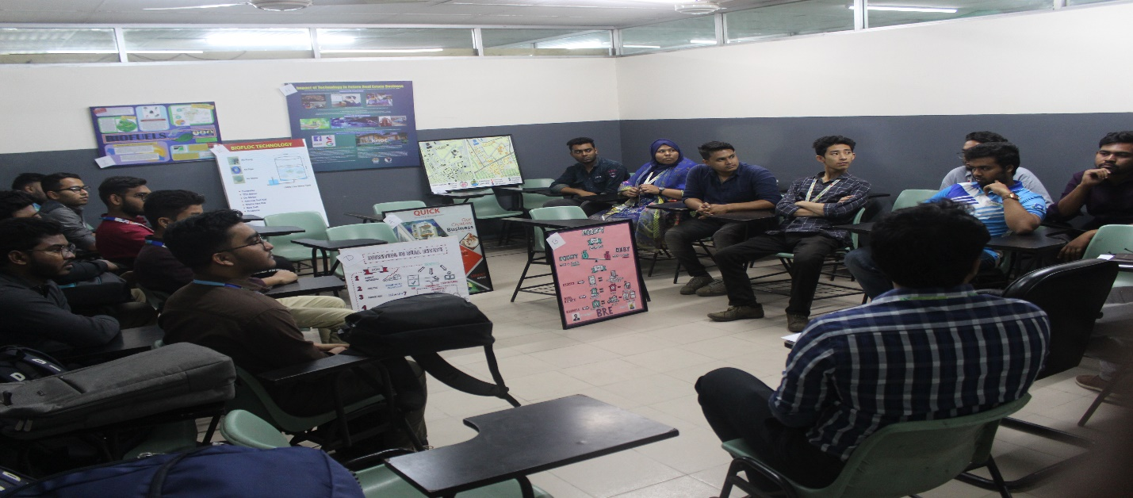
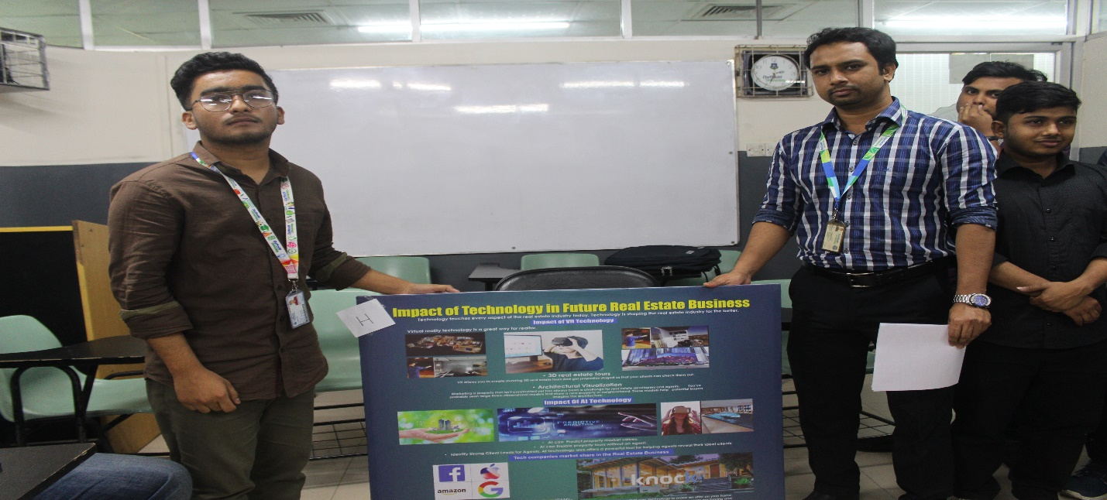
Department of Real Estate has organized the Intra Departmental Poster Competition on 18th February 2020 (Tuesday) at 1:00 pm in room-708, Daffodil Tower. Mr. Nurul Mohammad Zayed (Head of the Department), Mr. Md. Shakil Ahmed (Lecturer, Dept. of Real Estate) were the judges of the competition. Among Nine teams, “Team-H; Impact of Technology in Future Real Estate Business” became champion. Mr. Shakil Ahmed emphasized on the necessity of feasibility of the project in his speech while Mr. Nurul Mohammad Zayed, Head of the department of Real Estate chaired the session and focused on the implementation of the projects. The poster competition was guided by Ms. Fatema Nusrat Chowdhury, Assistant Professor of the Department of Real Estate. The speakers of the session shared their experiences and growing scope for BRE graduates with the audiences. Research may solve many problems of the real estate industry which will further broaden the career opportunity of the graduates, they added. The session was attended by a good number of students and faculty members.
Champion “Team-H; Impact of Technology in Future Real Estate Business”

