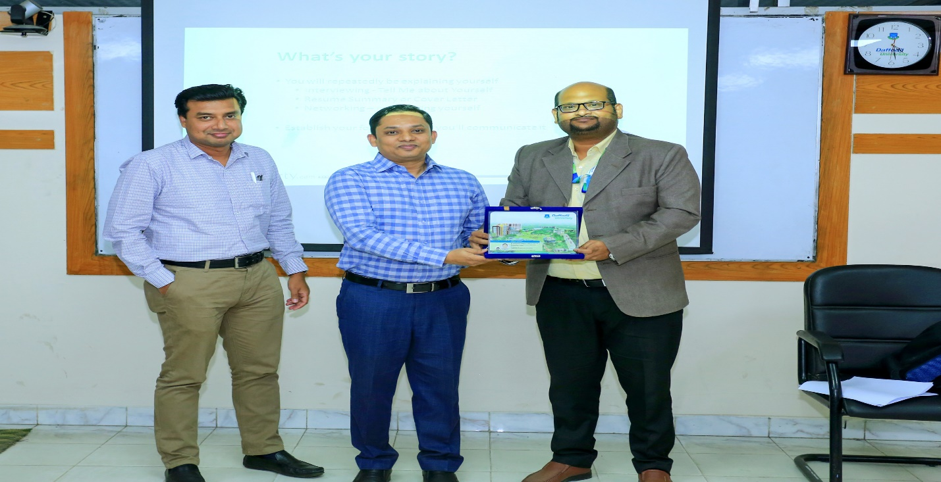
Mr. Nurul Mohammad Zayed (Head, Department of Real Estate) with other guest handed over the crest to Mr. Muhammad Mahfuzur Rahman Chowdhury; Manager, HR Department, Bproperty.com Limited.

The Department of Real Estate organized a seminar on "Career Plan & Career in the 21st Century” on 14 March 2020 at Digital classroom.-604, 6th Floor, Daffodil Tower. The key person for the seminar was Mr. Muhammad Mahfuzur Rahman Chowdhury, who is the Manager, HR Department, Bproperty.com Limited. He has extensive working experience in both real estate and housing sector, other private sectors and with multilateral and bilateral organizations.
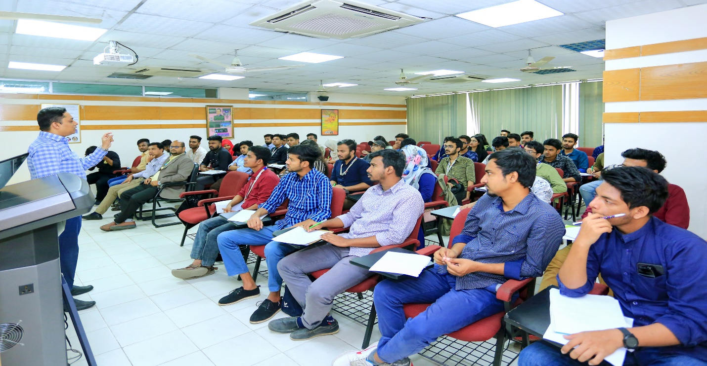
Mr. Muhammad Mahfuzur Rahman Chowdhury delivering speech on the seminar on "Career Plan & Career in the 21st Century””
He introduced students with tools and techniques, and various methods to make them eligible for building their career in the 21st century. He said, networking is very essential for development of professionalism. You should develop your professionalism by own. It’s not easy matter to create professionalism. Professionalism can be developed through hard working and integrity, he added.

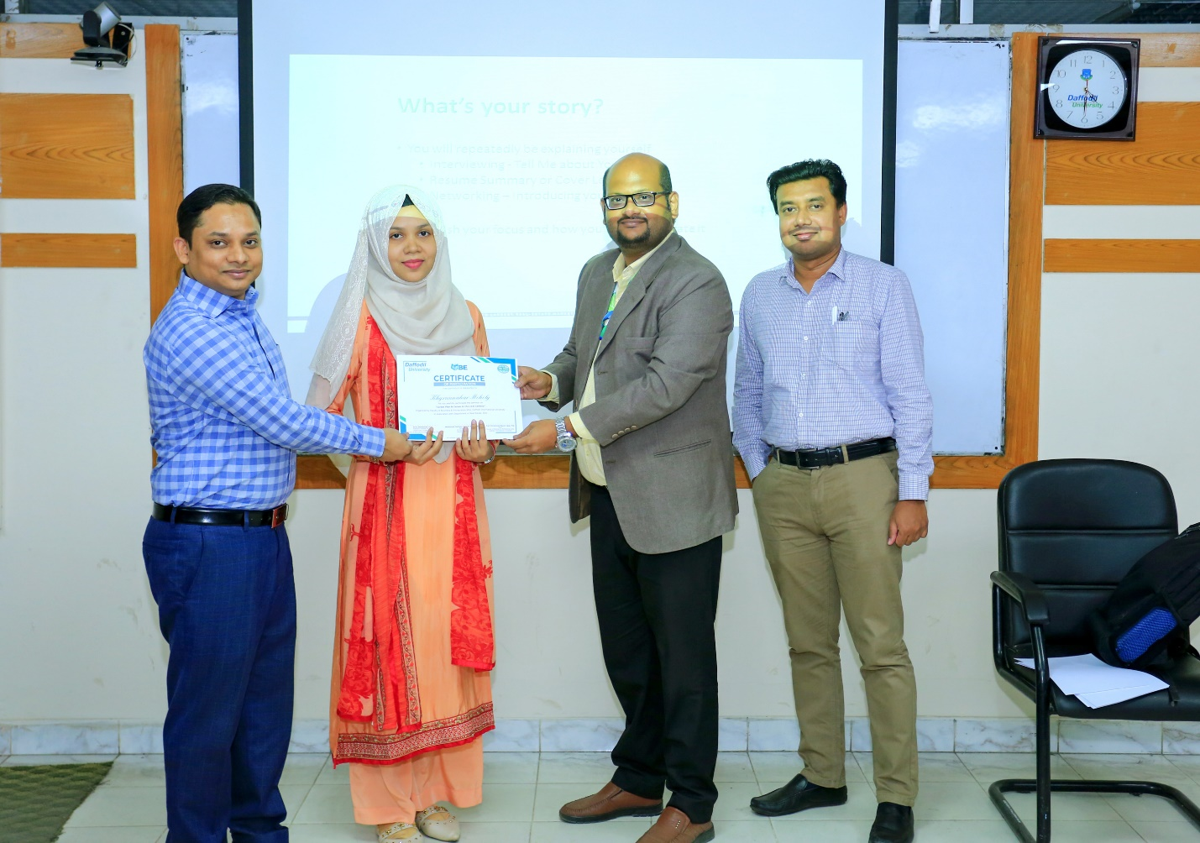
One of the students of Real Estate Department receiving certificate from the Key note speaker of the seminar and the Head of the Department.

Mr. Nurul Mohammad Zayed (Head, Department of Real Estate) thanked Mr. Muhammad Mahfuzur Rahman Chowdhury for sharing his valuable time and knowledge with BRE program students. He also thanked other faculty members for their support in organizing such an important seminar. The Seminar ended with the discussion for the development of Real Estate Department.

